EXPERIMENT 1

AIM:
Demonstrate inline, internal, and external JavaScript; use console methods; create a web[age showing user info and a welcome.

Software/Tools Required:
- Visual Studio Code (VS Code)
- Web Browser (Google Chrome/Microsoft Edge)
- HTML
- JavaScript (ES6)

Theory:
JavaScript is a scripting language used to make web pages interactive and dynamic. It can be added to an HTML page in three ways: inline JavaScript (inside HTML elements), internal JavaScript (inside the <script> tag, and external JavaScript (in a separate .js file linked to the HTML page). JavaScript also provides console methods such as console.log(), console.warm(), and console.error() for debugging and displaying messages. In this experiment, JavaScript is used to display user information and a welcome message on a webpage while demonstrating different ways of adding JavaScript to HTML.

Output:
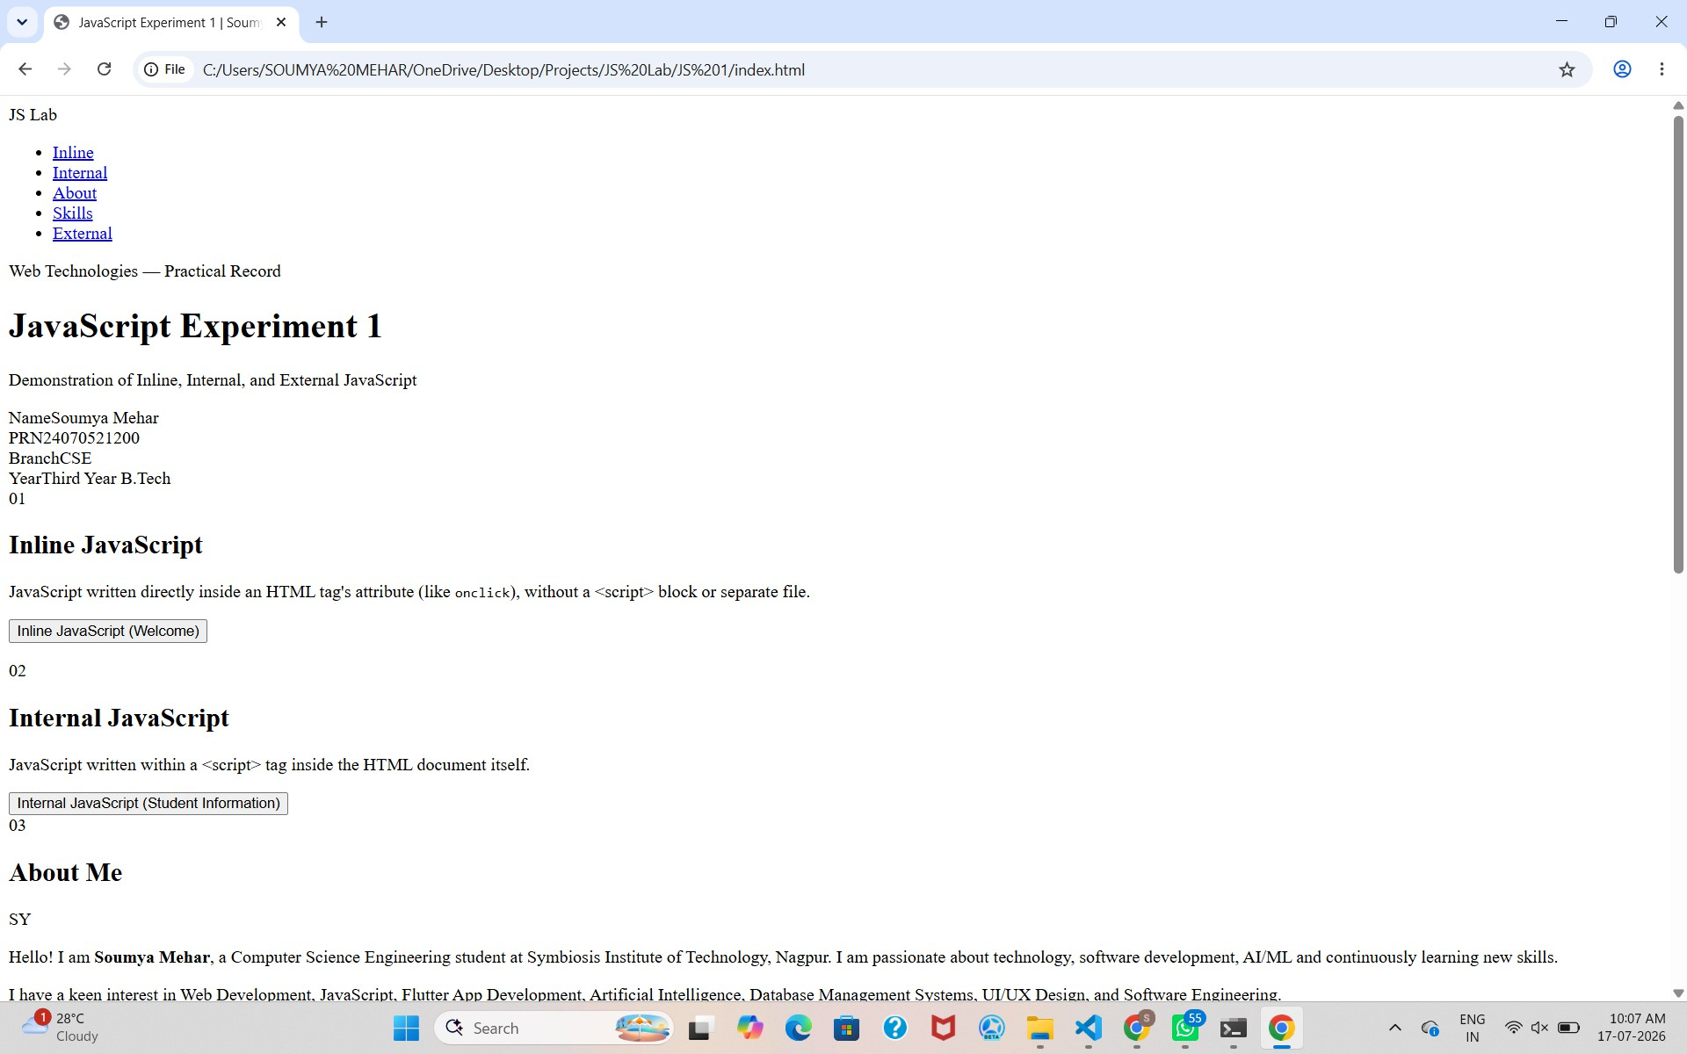

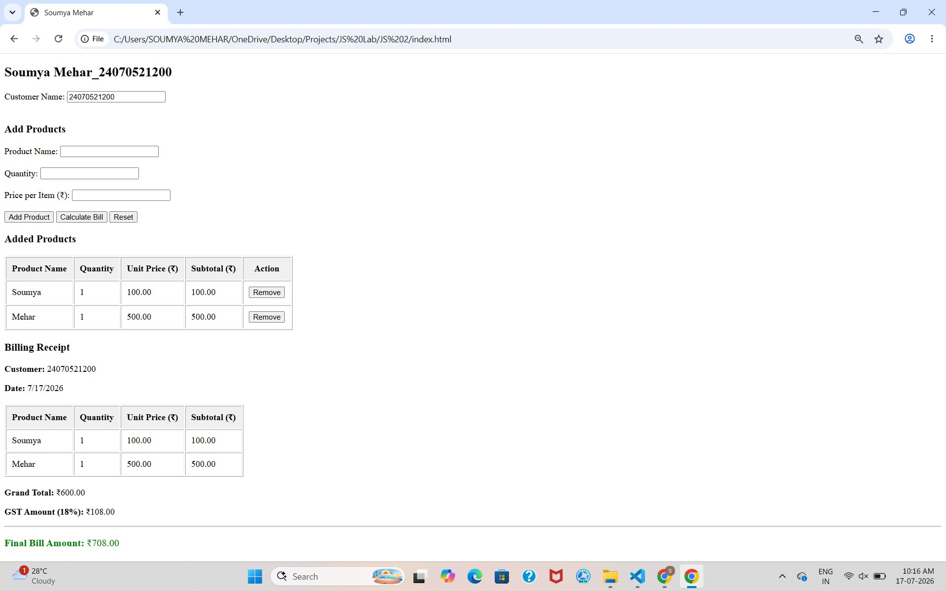

Result:
Successfully implemented a billing calculator using JavaScript ES6 features, including var, let, const, template literals, and destructuring, to calculate and display billing details accurately.

CASE STUDY 1

AIM:
Create a webpage for the college department and link the student information and write a JavaScript program to display “Welcome to SIT Nagpur”.

PROGRAM CODE:
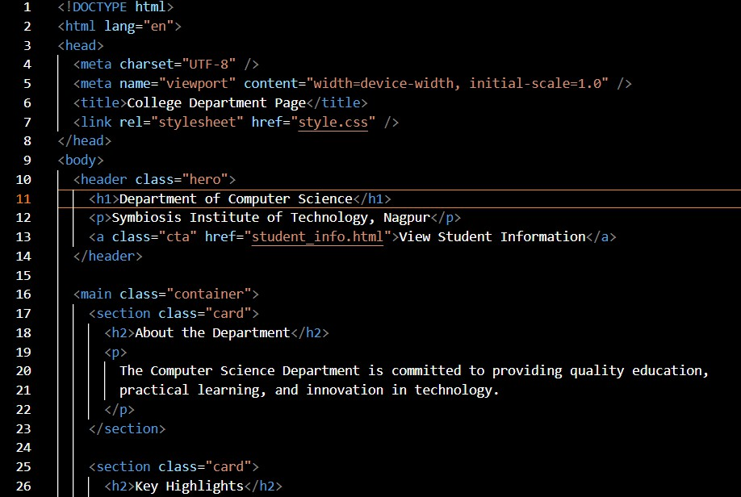

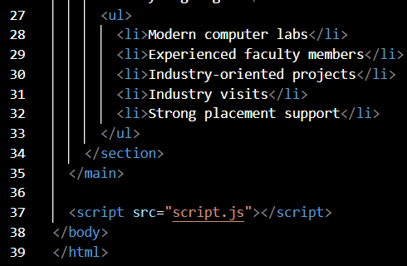

OUTPUT:
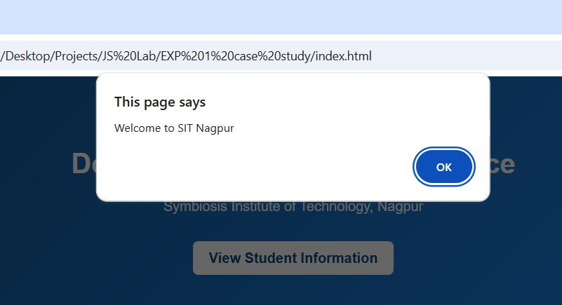

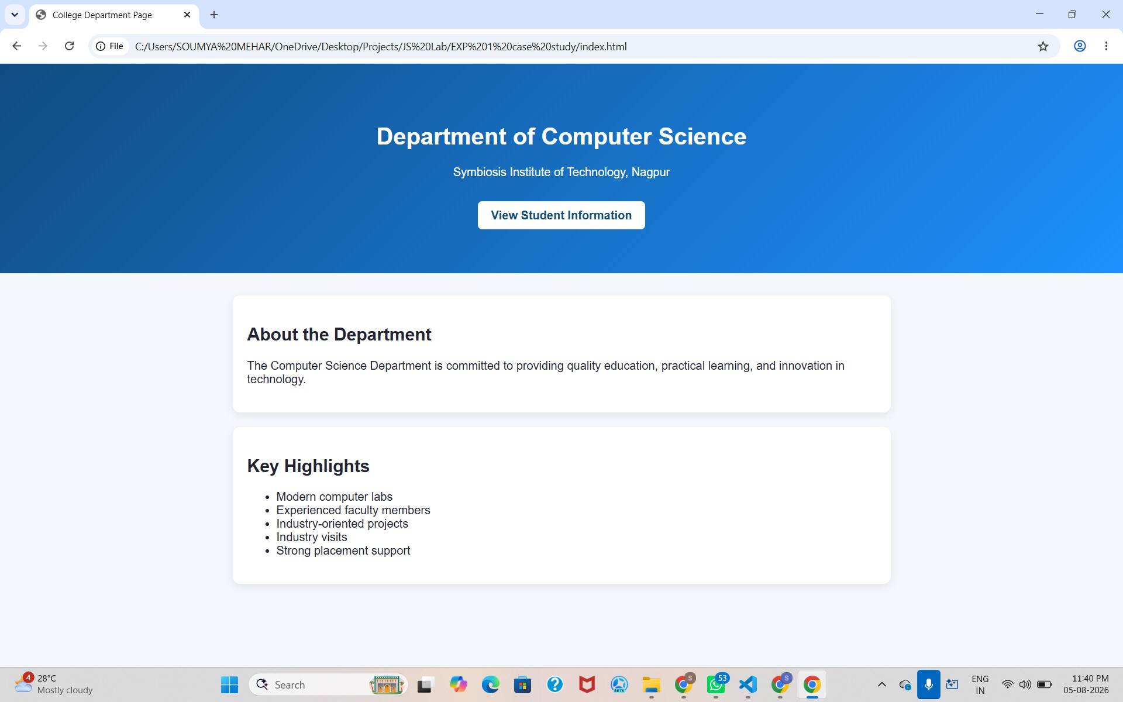

RESULT:
A webpage for the college department was successfully created using HTML, CSS, and JavaScript. Student information was linked and displayed correctly, and the JavaScript program successfully displayed the message "Welcome to SIT Nagpur" on the webpage. Thus, the aim of creating a college department webpage and implementing JavaScript functionality was achieved successfully.

EXPERIMENT 2

AIM:
To use var, let, and const, and demonstrate ES6 features like template literals and destructuring by building a billing calculator.

Software/Tools Required:
- Visual Studio Code (VS Code)
- Web Browser (Google Chrome/Microsoft Edge)
- HTML5
- JavaScript (ES6)

Theory:
JavaScript ES6 (ECMAScript 2015) introduced several modern features that make programming more efficient, readable, and easier to maintain. Among these features are var, let, and const, which are used for variable declaration. The var keyword has function scope and allows variables to be redeclared and updated. The let keyword provides block scope and allows variables to be updated but not redeclared within the same scope. The const keyword is also block-scoped and is used to declare constants whose values cannot be reassigned after initialization.
Template literals are another important ES6 feature that simplify string creation and formatting. They use backticks ( ) instead of quotation marks and allow variables and expressions to be embedded directly into strings using ${expression}. This eliminates the need for string concatenation and improves code readability.
Destructuring is a convenient JavaScript feature that enables the extraction of values from arrays or properties from objects into separate variables. It reduces repetitive code, makes variable assignment more concise, and improves code clarity, especially when working with complex data structures.

In this experiment, a billing calculator is developed using HTML and JavaScript. The application accepts user inputs such as product details, quantity, and price, and performs calculations to determine the total bill. Variables are declared using var, let, and const wherever appropriate, while template literals are used to display formatted billing information. Destructuring is applied to efficiently access and manage object or array values. This experiment demonstrates the practical implementation of modern JavaScript features in developing a simple, interactive, and user-friendly web application.

Output:


Result:
Successfully implemented a billing calculator using JavaScript ES6 features, including var, let, const, template literals, and destructuring, to calculate and display billing details accurately.

CASE STUDY 2

AIM:
Develop the webpage for an online shopping website with using html,css and html tags and calculate bill,customer name,mobile no,invoice no,product no,quantity(kg),rate per kg,discount,GST,packing charges,payment mode(cash/card/UPI), Membership(yes/no).

PROGRAM CODE:
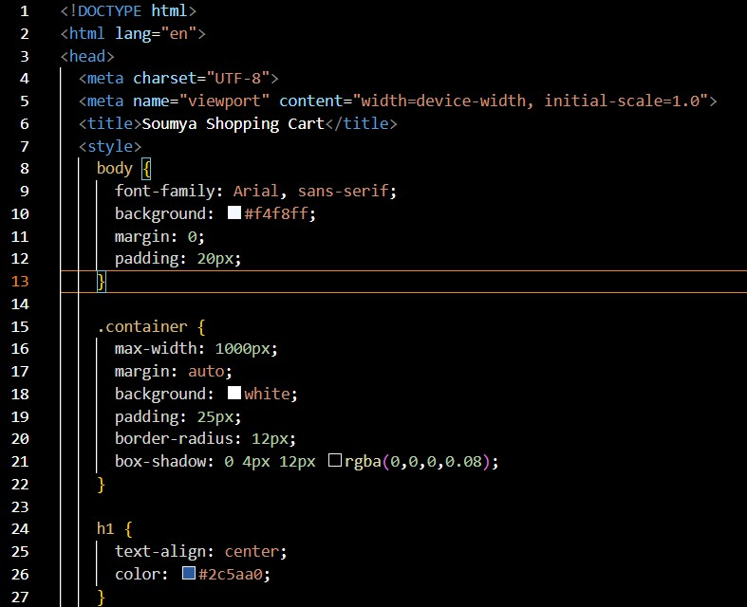

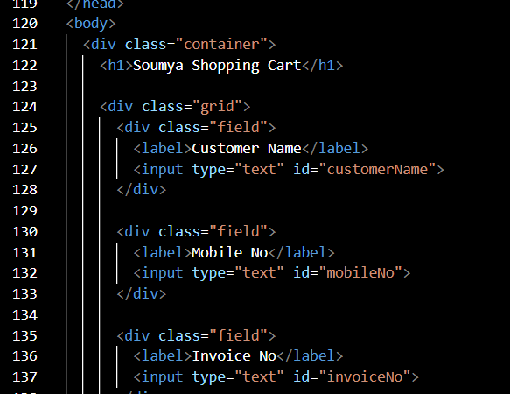

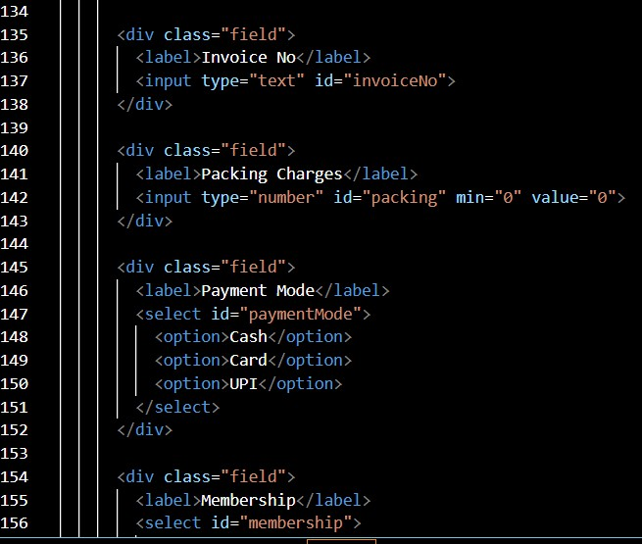

OUTPUT:
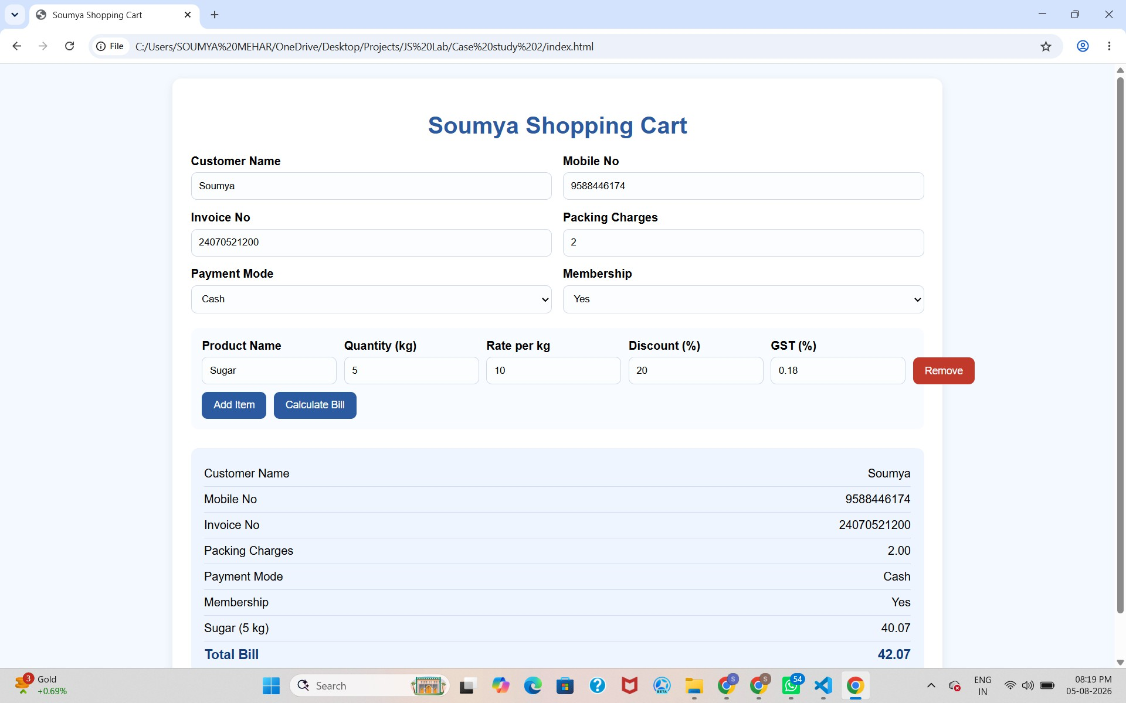

RESULT:
The online shopping billing webpage was successfully developed using HTML, CSS, and JavaScript. The program accepted customer and product details, calculated the total bill including discount, GST, and packing charges, and displayed the final invoice correctly. It demonstrated the use of user input, arithmetic calculations, objects, template literals, and object destructuring in JavaScript.

EXPERIMENT 3

AIM:
To implement JavaScript control structures and form validation by creating a grading system based on user-entered marks.

Software/Tools Required:
- Visual Studio Code (VS Code)
- Web Browser (Google Chrome/Microsoft Edge)
- HTML5
- JavaScript (ES6)

Theory:
JavaScript is a widely used scripting language that enables interactive and dynamic behavior on web pages. One of its key features is the use of control structures, such as if, else if, else, and switch, which allow programs to make decisions based on specified conditions. These control structures help in executing different blocks of code depending on the values provided by the user, making applications more intelligent and responsive.
Another important concept in web development is form validation, which ensures that user input is accurate, complete, and within the expected range before it is processed. Validation helps prevent invalid or incomplete data from affecting the application's functionality. It checks conditions such as empty input fields, non-numeric values, and marks entered outside the valid range (0–100). This improves data integrity and enhances the overall user experience.
In this experiment, a grading system is developed using HTML and JavaScript. The user enters marks for different subjects through a form, and JavaScript validates the input before performing calculations. After successful validation, the program computes the total marks, percentage, grade, and pass/fail status. The grade is determined using conditional statements based on predefined percentage ranges, while the pass/fail status is decided according to the minimum passing criteria. This experiment demonstrates the

practical application of JavaScript control structures and form validation in building an interactive and reliable web application.

Output:
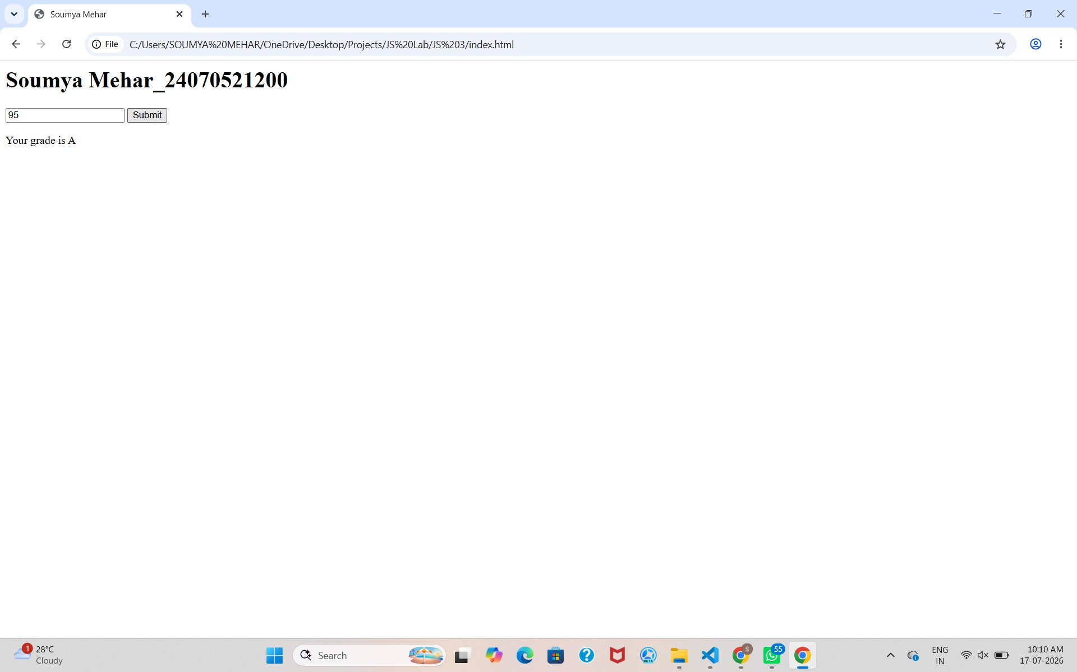

Result:
Successfully implemented JavaScript control structures and form validation to create a grading system that validates user input, calculates the total marks, percentage, grade, and pass/fail status accurately.

CASE STUDY 3

AIM:
Scholarship Eligibility,A college awards scholarships based on marks. Below 50-Not Eligible, 50-69-Bronze,70-84-Silver,85-94-Gold,95-100-Platinum.

PROGRAM CODE:
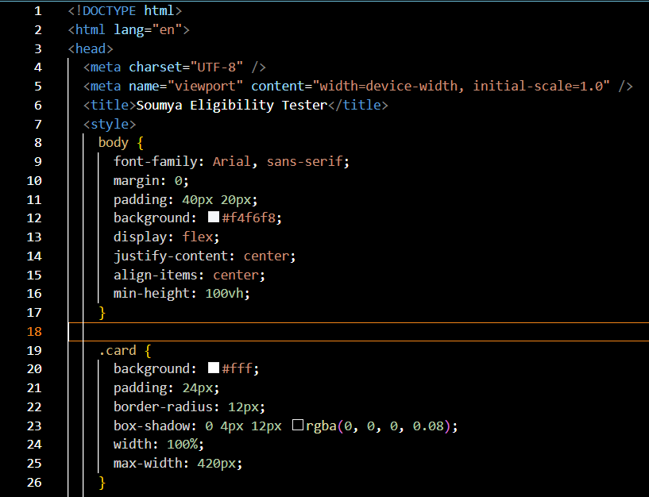

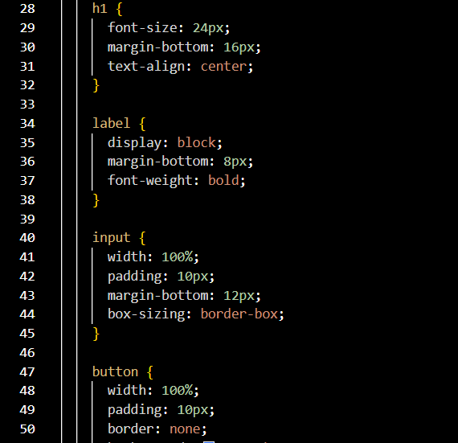

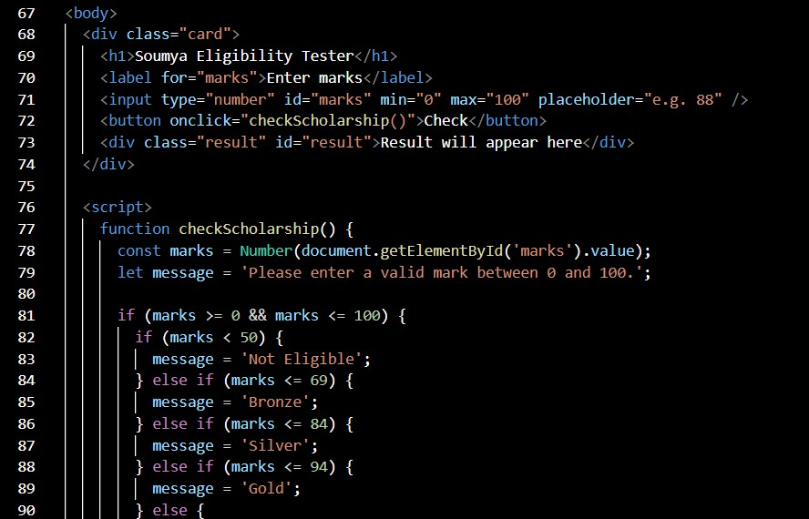

OUTPUT:
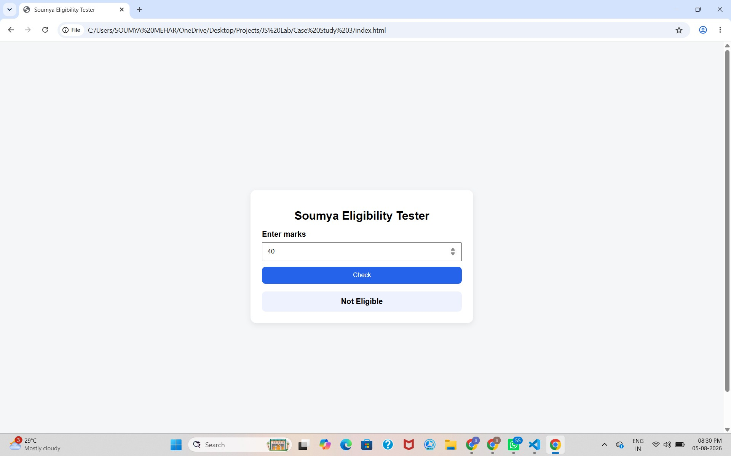

RESULT:
The Scholarship Eligibility was successfully implemented using JavaScript. The program validated the user input, assigned eligibility marks using if-else control structures, and displayed the correct Eligibility awards based on the entered marks. It effectively demonstrated the use of control structures and form validation in web development.

EXPERIMENT 4

AIM:
Use function types, scope and closures; apply try-catch; build a palindrome checker

Software/Tools Required:
- Visual Studio Code (VS Code)
- Web Browser (Google Chrome/Microsoft Edge)
- HTML
- JavaScript (ES6)

Theory:
A palindrome is a word, number, or sentence that reads the same forward and backward, such as MADAM, LEVEL, and 121. A palindrome checker is a program that checks whether the given input is a palindrome or not by comparing the original string with its reverse.
In JavaScript, different types of functions, such as function declarations, function expressions, and arrow functions, can be used to implement the palindrome checker. Variable scope determines where variables can be accessed in the program, while closures allow an inner function to access variables from its outer function.
The try-catch statement is used for exception handling and helps manage errors, such as invalid or empty input, without stopping the execution of the program. Thus, a palindrome checker demonstrates the concepts of functions, scope, closures, and error handling in JavaScript.

Output:
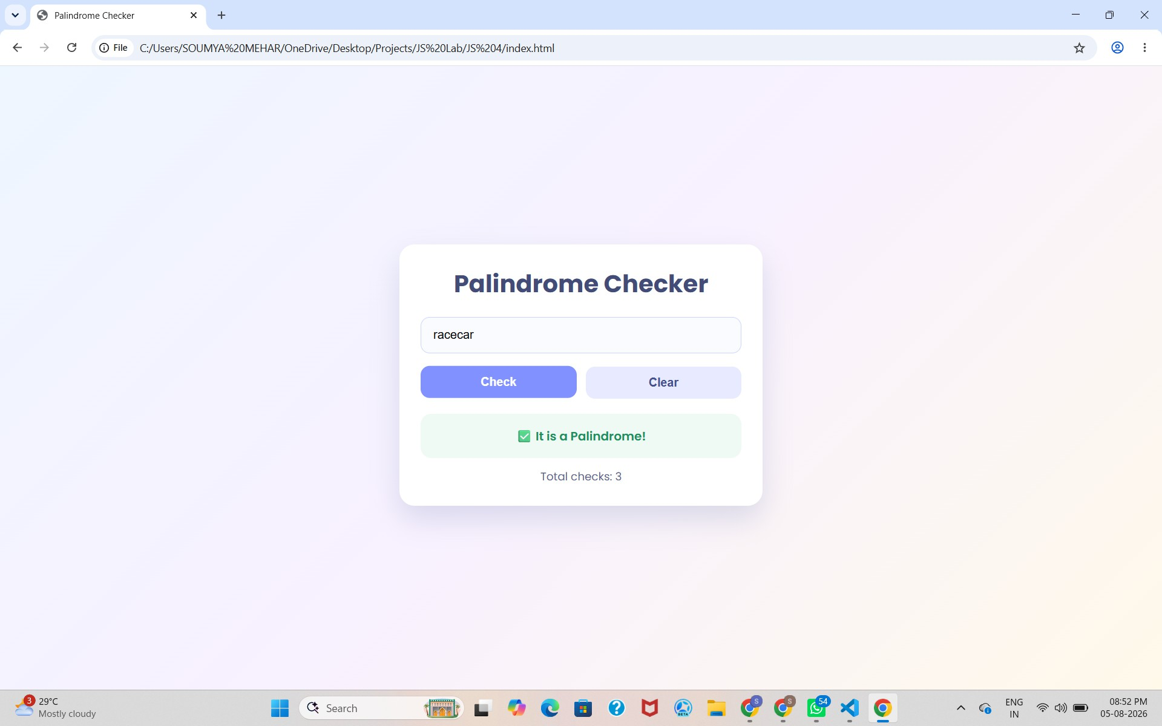

Result:
Successfully implemented a Palindrome detector using JavaScript ES6 features, including var, let, const, template literals, and destructuring, to find and display whether the given text or number is a palindrome or not.

CASE STUDY 4

AIM:
The ATM system verifies if the pin is palindrome. If the palindrome displays a security message. To implement this create a function to reverse the entered pin number and another function to check if it is palindrome. use function declaration, function expression, arrow function and demonstrate scope and closure concepts.

PROGRAM CODE:
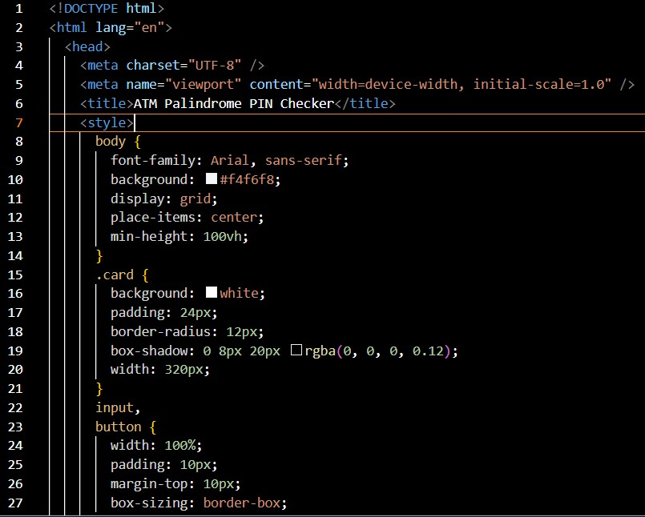

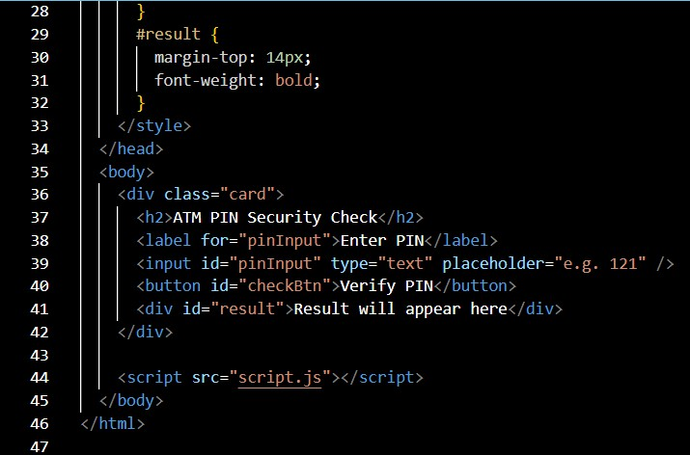

OUTPUT:
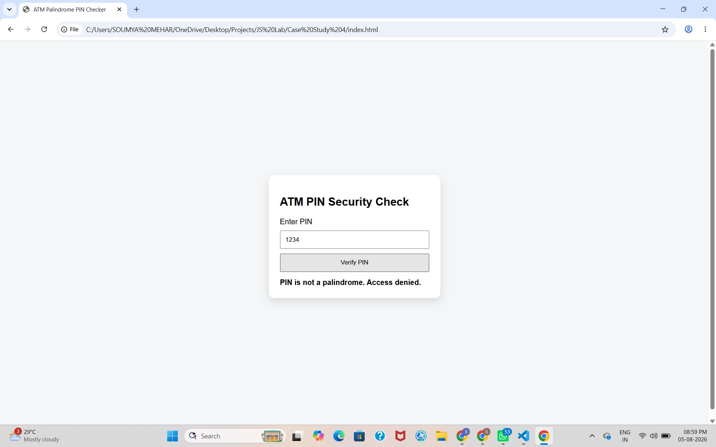

RESULT:
Successfully implemented a ATM pin Palindrome detector using JavaScript ES6 features, including var, let, const, template literals, and destructuring, to find and display whether the given ATM pin is a palindrome or not.

